DATA DRIVEN INOVATIONS IN SUPPLY CHAIN MANAGEMENT WITH QLIK INSIGHTS

1. INTRODUCTION
   1. Overview

The project centers on utilizing its data resources to optimize supply chain operations and enhance customer satisfaction. By analyzing datasets covering product management, sales, and customer interactions, the project aims to extract actionable insights for informed decision-making throughout the organization. Objectives include refining inventory management processes, tailoring customer experiences through targeted marketing and product recommendations, and cultivating a data-driven mindset. Anticipated outcomes encompass enhanced supply chain efficiency, elevated customer satisfaction, and improved strategic decision-making abilities. The project documentation will comprise a detailed analysis report, practical strategy recommendations, an implementation blueprint, and defined performance metrics for monitoring progress and success. Through this endeavor, DataCo Global seeks to fortify its competitive stance in the retail landscape while maximizing operational efficiency and customer engagement.

* 1. Purpose

The purpose is to harness the power of data analytics to streamline supply chain operations and enhance customer satisfaction. By delving into datasets encompassing product management, sales, and customer interactions, the project aims to uncover valuable insights that will drive efficiency and satisfaction throughout the organization. Through a methodical approach encompassing data analysis techniques such as descriptive analytics and predictive modeling, coupled with stakeholder consultations, the project seeks to derive actionable recommendations for improving inventory management and personalizing customer experiences. With a clear focus on delivering tangible outcomes, including a comprehensive data analysis report, strategy recommendations, and an implementation plan, the project aims to address key objectives within a defined timeline. By involving key stakeholders and proactively addressing potential risks, the project aims to position DataCo Global for sustainable growth and success in the competitive retail landscape.

* 1. Technical Architecture

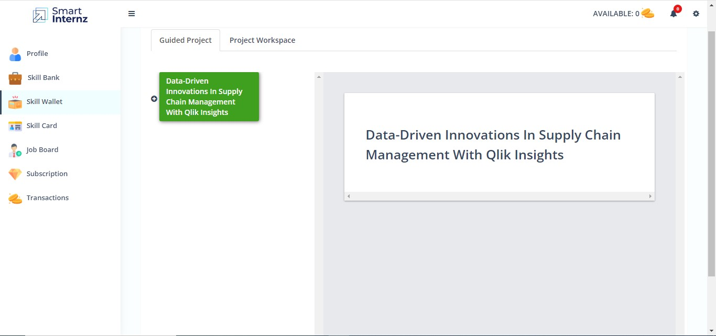

1. **PROBLEM UNDERSTANDING**
   1. Specify the business problem

This project aims to revolutionize supply chain management through data-driven insights using   Qlik. Leveraging advanced analytics, it seeks to optimize logistics, forecasting, and inventory management, enhancing operational efficiency and responsiveness.   
This transformative project endeavors to reshape the landscape of supply chain management by harnessing the power of Qlik's data-driven insights. Employing cutting-edge analytics, it strives to revolutionize key facets such as logistics, forecasting, and inventory management, with the overarching goal of elevating operational efficiency and responsiveness to new heights.

### Business Requirements

### Implement a robust data integration strategy to aggregate and centralize relevant data from diverse supply chain sources. Utilize Qlik's advanced visualization capabilities to create intuitive and dynamic dashboards, providing stakeholders with clear insights into the entire supply chain ecosystem. Leverage Qlik's advanced analytics features to analyse historical logistics data, identify patterns, and optimize transportation routes. Implement real-time tracking and monitoring solutions to enhance visibility into the movement of goods, reducing lead times and minimizing transportation costs. Implement real-time analytics to facilitate quick decision-making in response to unforeseen events or changes in demand, ensuring a proactive and responsive supply chain.

### 2.3 Literature Survey

A literature survey on the project theme of revolutionizing supply chain management through data-driven insights and advanced analytics reveals a growing body of research and scholarly articles focused on similar endeavors. Studies underscore the increasing recognition of the pivotal role that data analytics plays in transforming traditional supply chain processes. Research highlights the effectiveness of leveraging advanced analytics tools, such as Qlik, to enhance visibility and decision-making in supply chain operations. The study emphasizes the positive impact on logistics optimization, forecasting accuracy, and inventory management efficiency. Moreover, delves into the broader landscape of data-driven supply chain transformations, exploring diverse analytical techniques and technologies. The findings showcase successful implementations, demonstrating notable improvements in operational efficiency and responsiveness across various industry sectors. In addition, examines the challenges and opportunities associated with the adoption of data-driven insights in supply chain contexts. The literature emphasizes the need for organizations to develop robust data governance frameworks and cultivate a data-driven culture to fully unlock the potential benefits.

2.4 Social Or Business Impact

**Social Impact Analysis:**

* Create visualizations to showcase the demographic distribution of Supply chain management
* Analyze how Data-Driven Innovations in Supply Chain Management have impacted social welfare programs, financial inclusion, and other key areas.
* Explore any correlations between usage and improvements.

**Business Impact Analysis:**

* Analyze how Data-Driven Innovations in Supply Chain Management have affected businesses, especially in sectors like banking,  telecommunications, and e-commerce.
* Evaluate the impact of Data-Driven Innovations in Supply Chain Management on sales, customer onboarding, and operational efficiency.

### Data Collection & Extraction From Database

Data collection is the process of gathering and measuring information on variables of interest, in an established systematic fashion that enables one to answer stated research questions, test hypotheses, evaluate outcomes and generate insights from the data.

* 1. Collect the Dataset: Understanding Data

Preparing the data for visualization involves cleaning the data to remove irrelevant or missing data, transforming the data into a format that can be easily visualized, exploring the data to identify patterns and trends, filtering the data to focus on specific subsets of data, preparing the data for visualization software, and ensuring the data is accurate and complete. This process helps to make the data easily understandable and ready for creating visualizations to gain insights into  performance and efficiency. Since the data is already cleaned, we can move to visualization.

3.2 Connect data with Qlik sense

Click here for link : <https://hlu3f360gwt9q08.sg.qlikcloud.com/dataset/6662bf205cd1f4b0e5cf9feb>

1. Data Preparation:

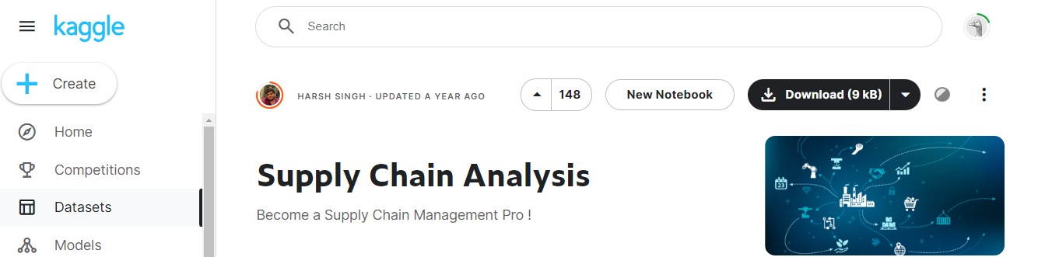

After preparation : <https://docs.google.com/spreadsheets/d/1ZcZMmoZcwjkPYx9blWzOh9TxSd18Hhoh/edit?usp=drive_link&ouid=109010283295156709409&rtpof=true&sd=true>

1. **Data Visualization**

**5.1 VISUALIZATIONS**

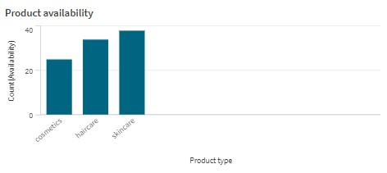

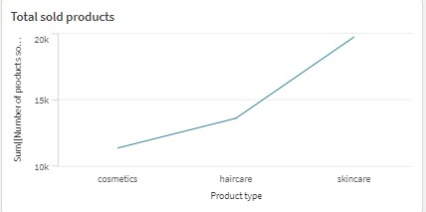

1. **DASHBOARDS**
   1. Responsive and Design Of Dashboard

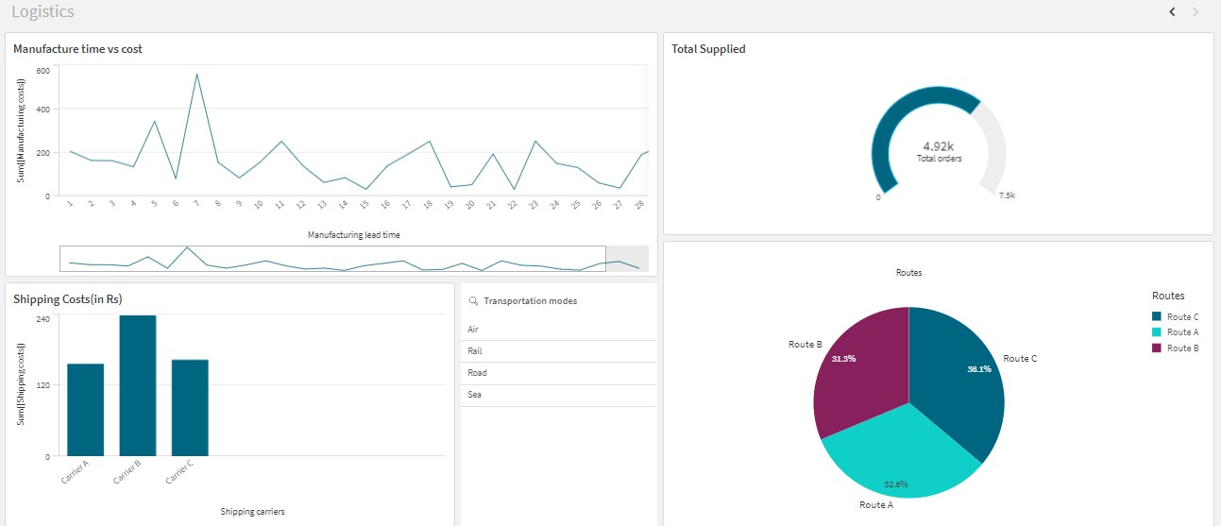

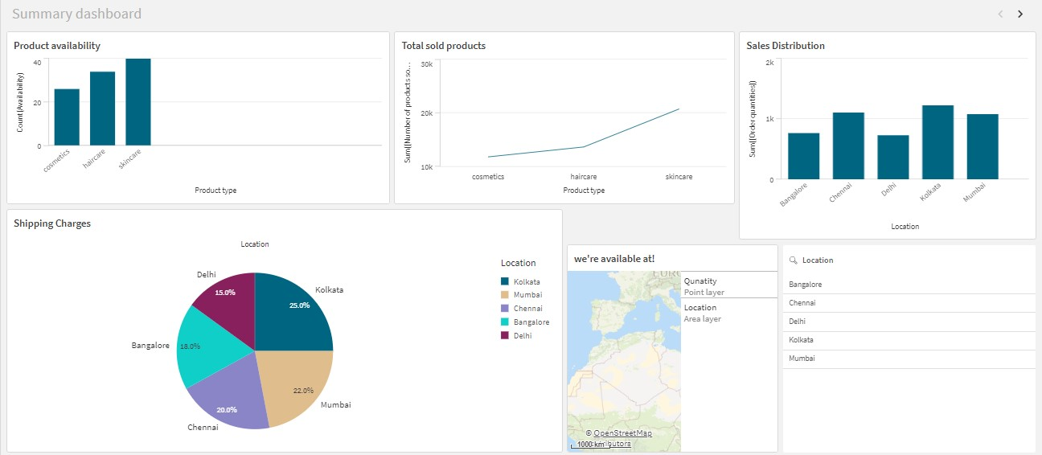

1. **Report**
   1. Report Creation

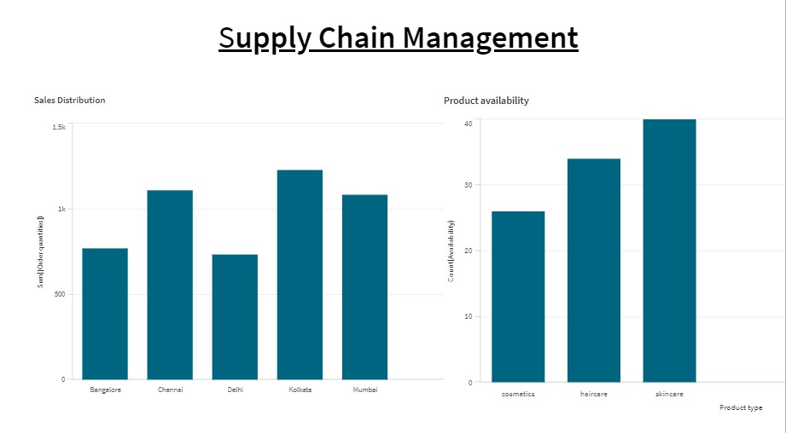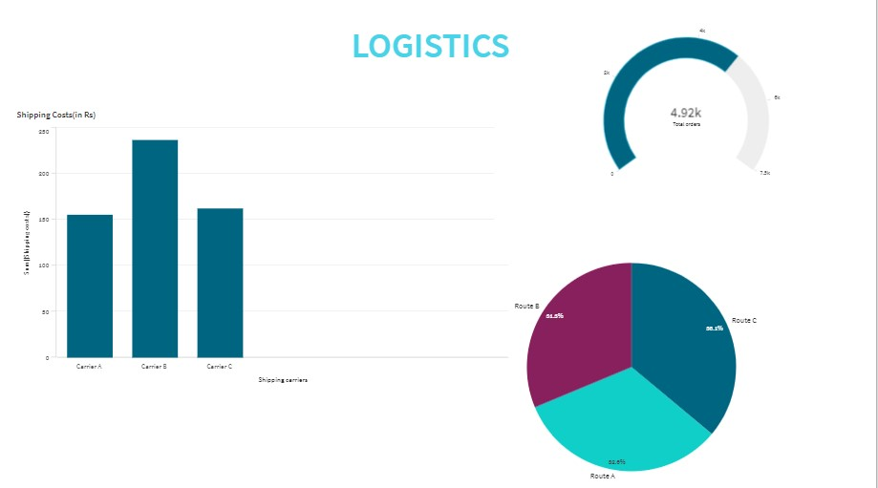

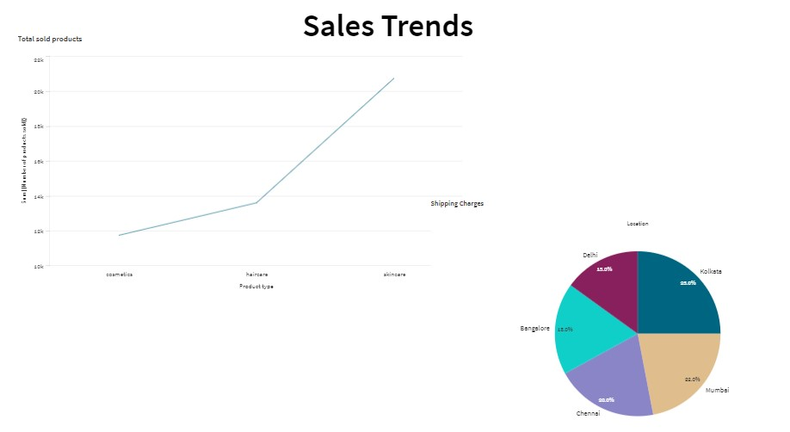

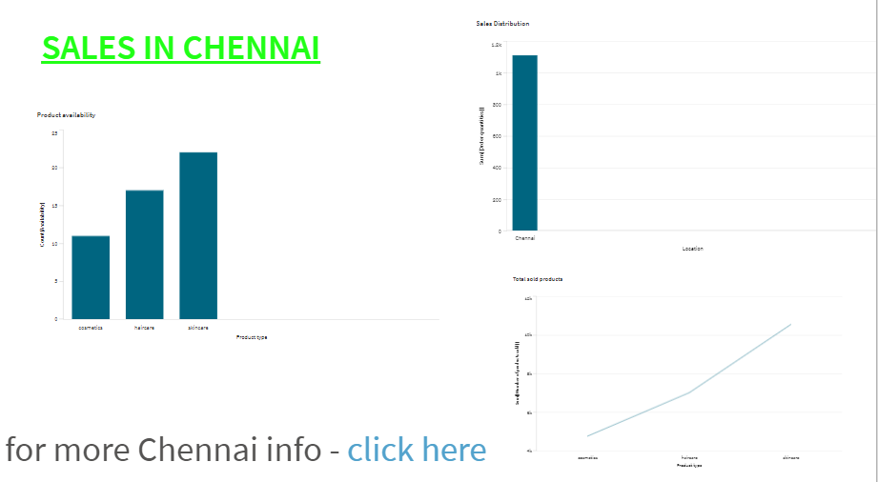

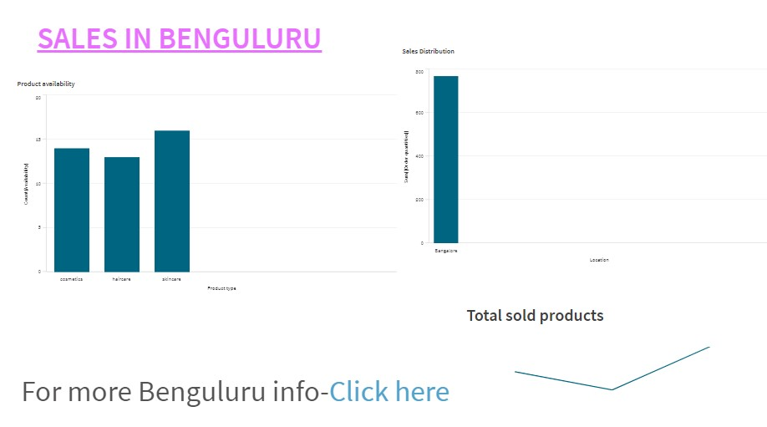

1. **Performance Testing**
   1. Amount of Data Rendered

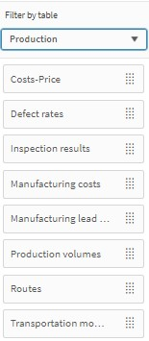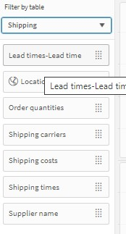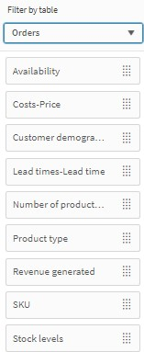

* 1. Utilization of Data Filters

